**Class Activity – Lesson 18**

1. Did you attend class today (8 pts)
2. Were you on time to class today (4 pts)?
3. At the beginning of the semester, Brother Cromar’s students filled out a survey. One of the questions asked if students were willing to date a shorter male if you are female, or taller female if you are male. You would like to test to see if there is a proportion difference between the two genders. Use a level of significance of α = 0.05.
   1. (1 pt.) Show the descriptive statistics for this analysis.

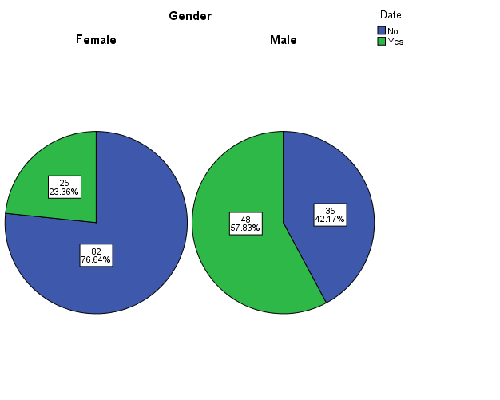

**Standard Deviation = 0.0679 for confidence interval and Standard Deviation =0.0711 for hypothesis test.**

**Note: for the rest of the problem, you will need to get the information from your pie charts or bar graphs from part (a).**

* 1. (1 pt.) Check the requirements for doing this hypothesis test. What do you assume based on your findings

**Female sample - $n*\hat{p}=107* 0.234=25 and n*(1-\hat{p})=107*(1-0.234)=82$**

**Male sample - $n*\hat{p}=83* 0.578=48 and n*(1-\hat{p})=83*(1-0.578)=35$**

**We assume that the sampling distributions of $\hat{p}$ for both groups are normal.**

* 1. (1 pt.) State the null and alternative hypotheses

**Ho:p1=p2 Ha:p1≠p2**

* 1. (1 pt.) Compute the Test Statistic

**Z=-4.845**

* 1. (1 pt.) Compute the P-value

**p-value = 0.000**

* 1. (1 pt.) What decision do you make about the null hypothesis based on the decision rule?

**Since our p-value is less than α, we reject the null hypothesis.**

* 1. (1 pt.) State your conclusions in “layman’s terms”.

**We have sufficient evidence to say that the proportion of men who are willing to date women against the height norm is different than the proportion of women.**

* 1. (1 pt.) Calculate and interpret the 95% confidence interval of the proportion difference between genders.

**We are 95% confident that the proportion difference is between -0.478 and**

**-0.212.**

* 1. (1 pt.) Check the requirements for doing a confidence interval for the proportion difference between gender

**Female sample - $n*\hat{p}=107* 0.234=25 and n*(1-\hat{p})=107*(1-0.234)=82$**

**Male sample - $n*\hat{p}=83* 0.578=48 and n*(1-\hat{p})=83*(1-0.578)=35$**

**We assume that the sampling distributions of $\hat{p}$ for both groups are normal.**

* 1. (1 pt.) Based on the confidence interval, is there a difference in the proportion of students willing to date someone against the norm between genders?

**Since zero is not in the confidence interval, we can say that there is a difference between proportions across gender.**

|  |  |
| --- | --- |
| **4.** | (1 pt.) Suppose you had been in charge of designing the study. What sample size would be needed to construct a margin of error of 2% with 95% confidence? Use the prior point estimate of $p^*=0.15$for this calculation. Round up to the nearest whole number. (For example, 144.1 would round to 145) n= |
| **5.** | (1 pt.) Suppose you're testing H_o:\ p = 0.62against H_a:\ p != 0.62and you have calculated the test statistic to be z = 1.334. The area to the right of z = 1.334(under the standard normal density curve) is 0.091. Which one of the following is the P-value of your hypothesis test? |
|  | |  |  | | --- | --- | |  | 0.046 | |  | 0.091 | |  | 0.182 | |  | 0.909 | |  |  | |
| **6.** | (1 pt.) Suppose you are dog breeder and you want to use a confidence interval to estimate the true mean fertility levels of purebred cocker spaniels. It is known that the distribution of fertility levels of cocker spaniels is normal. How many measurements must you have in order to be sure the sampling distribution of barxis normal? |
|  | |  |  | | --- | --- | |  | n >= 30 | |  | n >= 10 | |  |  | |  | np >= 10and n(1 - p) >= 10 | |  | np >= 5and n(1 - p) >= 5 | |  | Any n will do. | |

|  |  |
| --- | --- |
| **7.** | (1 pt.) As part of his semester project, a BYU-Idaho Introductory Statistics student calculates a 95% confidence interval for the true percentage of BYU-Idaho students who are from Latin America. What does the phrase "95% confidence" mean? |
|  | |  |  | | --- | --- | |  | There's a 95% chance that the true proportion is in the confidence interval. | |  | 95% of the student's data are within the confidence intervals. | |  | If we create many 95% confidence intervals, 95% of them will contain the true proportion. | |  | The sample proportion is in 95% of the confidence intervals we make. | |
| 8. | (1 pt.) Different counties across the US have different property tax rates for residential properties. A financial economist wants to estimate the true mean US tax rate for residential properties. Which confidence interval would be most appropriate in this situation? |
|  | |  |  | | --- | --- | |  | One sample z-confidence interval | |  | One sample t-confidence interval | |  | Paired-samples t-confidence interval | |  | Independent samples t-confidence interval | |  | Confidence interval for one proportion | |